**Main step for write a simple test case “Create a campaign”**

**Create testcasedata, contact list file, strategy file**

You should copy existing files then modify it follow requirement of your test case.

**Testcasedata (xlsx file):** contain all data for test suite. Link : src\test\java\com\data\testcasedata

(ex: RealTimeStatsSLTP.xlsx)

**Contact list file (csv file):** contain records need to add to contact list. Link : src\test\java\com\data\datafiles

(ex: sample01.csv)

**Strategy (xml file):** for import strategy. You can create strategy manual then export and put it to strategy folder. Link : src\test\java\com\data\strategy

(ex: previewCall.xml)

**Write test case in scripts**

Should refer to function (Ctr+click in function) for how to use

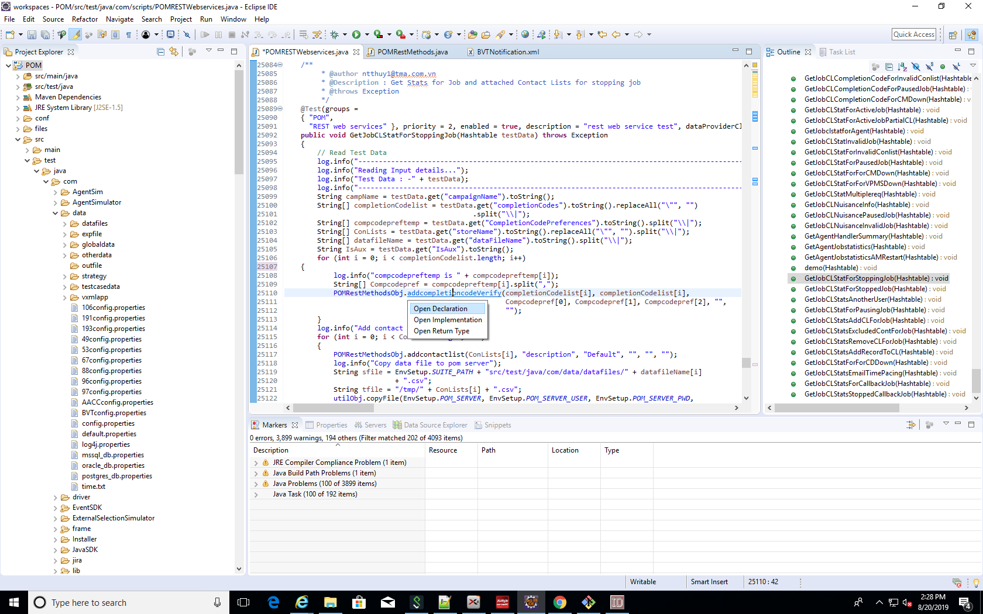

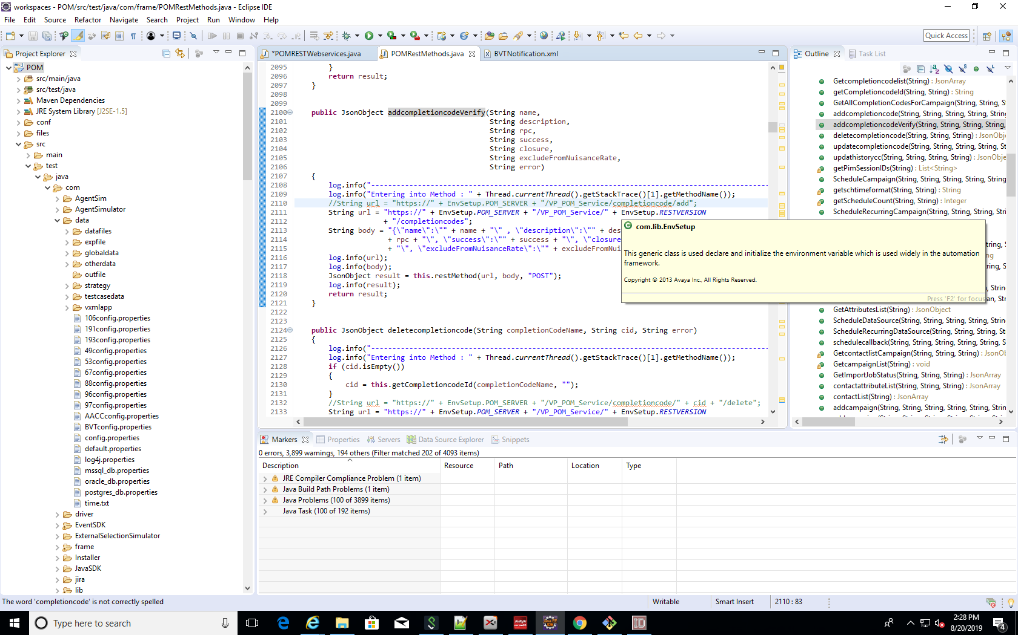

1. **Create all necessary variables from testData (dataFile)**

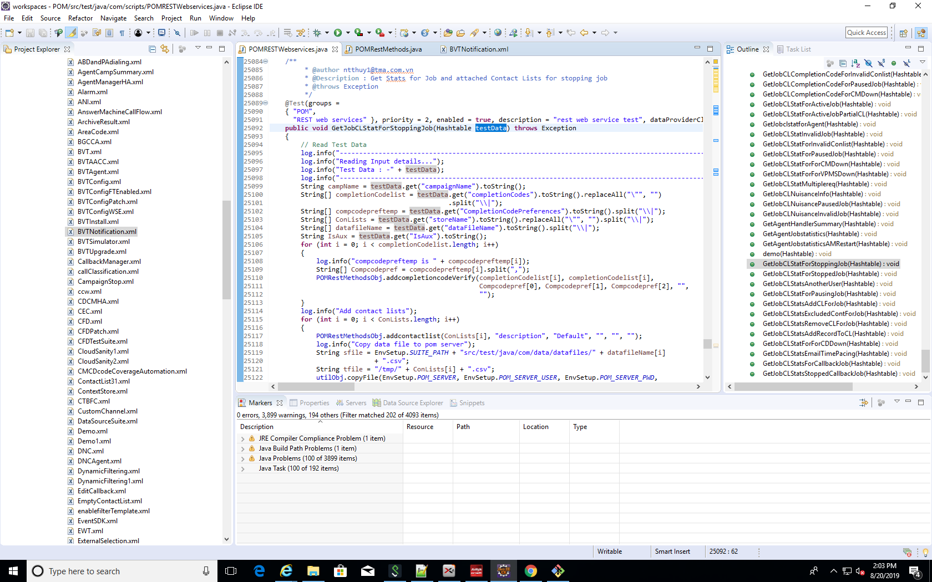Using : testData.get(“<parameter_name>”).toString()

1. **Create completion code**

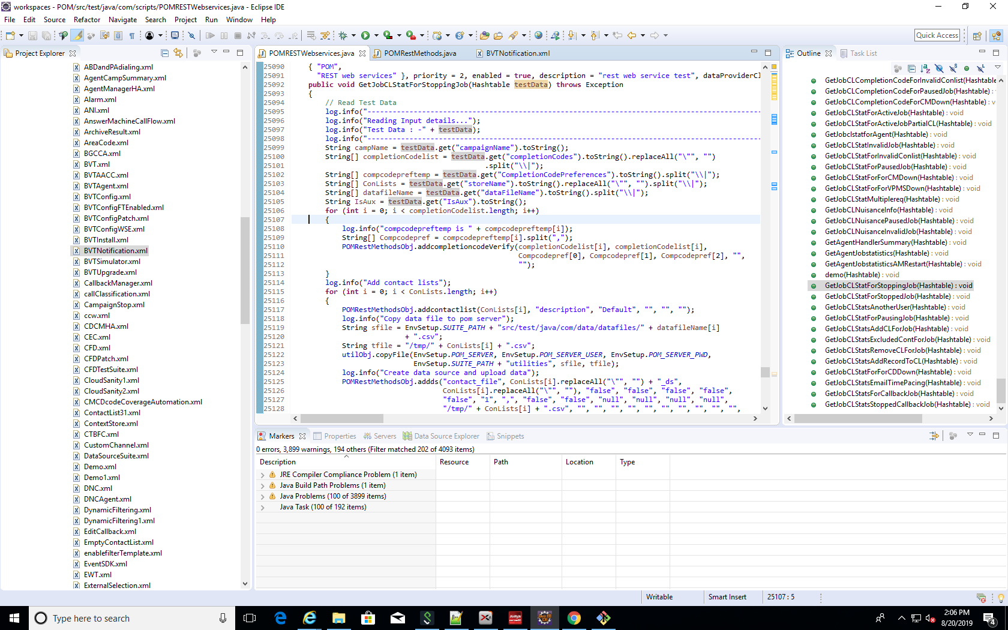Completion code in testcasedata need be matched with completion code in strategy.

1. **Create contact list**
2. 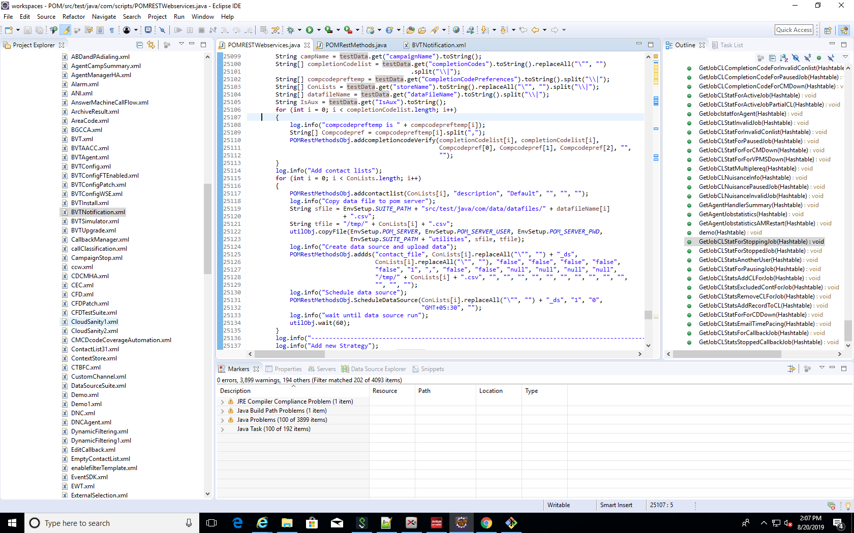**Create data source and upload records**
3. 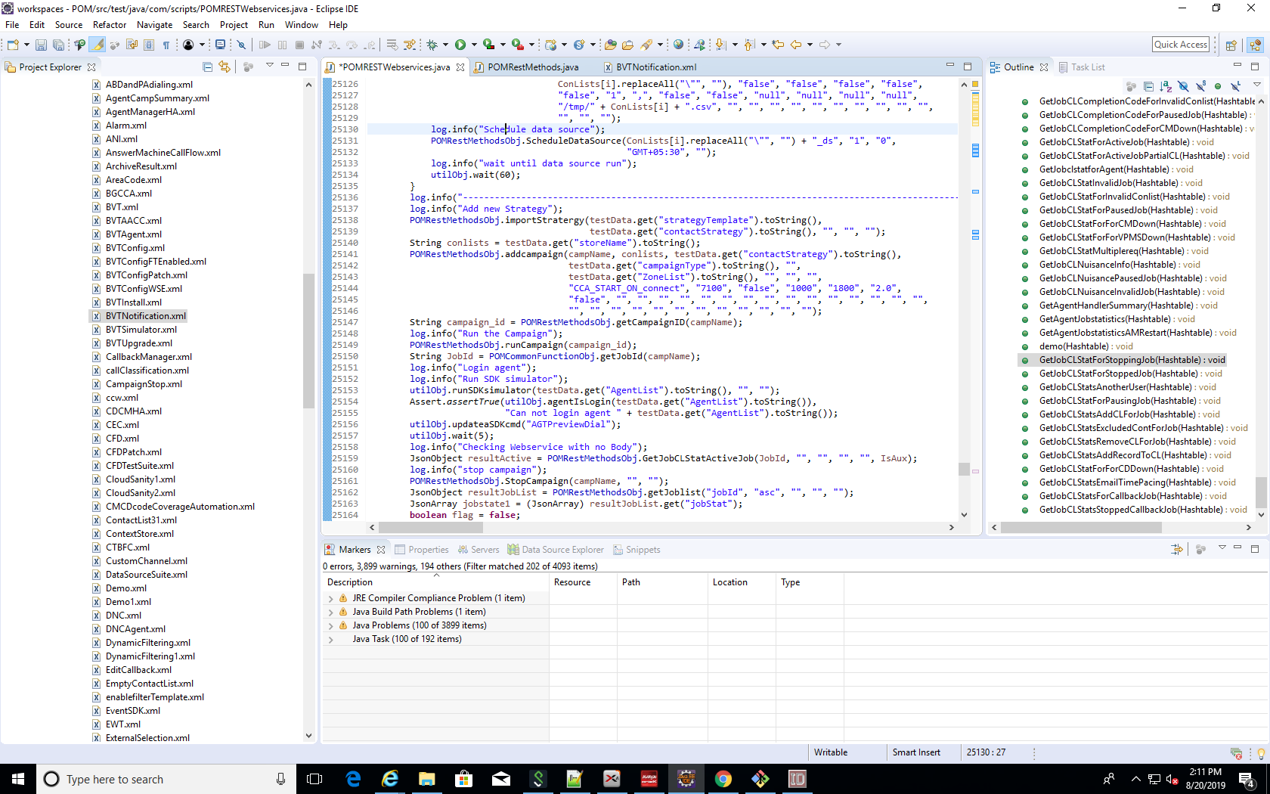**Import strategy**
4. **Add campaign**